**CHAPTER ONE**

**INTRODUCTION**

**1.1 Background of Study**

Mobile phones have become essential tools for communication and information exchange in the last two decades. Many people rely on their mobile phones in their personal lives as well as their businesses. Most mobile phone users exchange very sensitive and private information using their mobile phones assuming that the mobile phone network is reliable and secure (Mohan, 2018). In the present world every person is so engrossed in their mobile phones that they carry it with them almost everywhere which also includes the restricted areas like examination halls, conference halls, meeting rooms, court rooms, petrol stations and many more places. This hampers the privacy and security of that place. This can be prevented by installing GSM signal frequency jammers in these places, but when left active for long time it can be dangerous for the environment as it emits radiations (Mohan, 2018). To overcome this issue we can use a detector which activates the jammer. GSM signal jammer is a device which blocks transmission by creating interference. A GSM jammer is a device that transmits a signal on the same frequency at which the GSM operates.

The jamming succeeds when the mobile phones in the area where the jammer is located are disabled. In recent times, where bombs are being planted and detonated by GSM signals, this device can be at an advantage by jamming the signals required for the detonation of the bomb. Presently, the mobile phone jammer devices are becoming civilian products rather than electronic warfare devices, since with the increasing number of the mobile phone users in specific places would be disruptive. These places include worship places, university lecture rooms, libraries, concert halls, meeting rooms, and other places where silence is appreciated.

The solution to these annoying and disrupting noises is to install a device which can block the signal transmission from mobile phones. Jamming devices overpower the cell phone by transmitting a signal on the same frequency and at a high enough power that the two signals collide and cancel each other out. Cell phones are designed to add power if they experience low-level interference, so the jammer must recognize and match the power increase from the phone. To jam a cell phone, all you need is a device that broadcasts on the correct frequencies (Mohan, 2018). Although different cellular systems process signals differently, all cell-phone networks use radio signals that can be interrupted. GSM, used in digital cellular and PCS-based systems, operates in the 900 MHz and 1800 MHz bands

**1.2 Problem Statement**

Due to the increasing sophistication and high technology, most people are using mobile phones. Mobile phones have become a very important communication tool today. With the use of the mobile phones everywhere, it becomes an annoying device while working, studying, praying and many more. The GSM frequency signal jammer have been made to curb all of this\but considering the fact that we keep experiencing evolution in modern technology which also contributes to the sophistication of bombs which are being triggered by GSM. We therefore have been able to make some researches that have been believed to enhance the performance of the GSM frequency Jammer which shall be further discussed in this project.

**1.3** **Aim and Objectives of the Study**

The aim of this work is to improve on the functions of a cell phone service jammer which restricts the use of handset in certain public places. The objectives are:

1. To Design a system capable of Jamming signals between the range of 900 MHz and 1800 MHz bands.
2. To make the GSM Frequency Jammer as Mobile and compact as possible.
3. To ensure that the system is able to cover a minimum of 5 meters’ range.
4. To ensure that the system is able to jam signals in different GSM devices regardless of brand or manufacturer.
5. To ensure that its able to constantly jam GSM signals for as long as it may be powered on.

**1.4** **Significance of the Study**

For school or university, by blocking cell phone signals, students cannot be distracted by their phones. In addition, they cannot cheat by sending text messages to one another during exams. That is why this project is stating out the core defects or lapses discovered from the already made GSM Frequency Jammer so that by implementing in the next phase of the project, it will meet up with the technological innovation and serenity that is needed all around. High security premises, such as prisons and detention centers, can also benefits from a jammer service because it can prevent illicit communication between inmates and visitors. Of course, a cell phone jammer can also be beneficial in places such as a movie theater or a library where other patrons expect silence so they can enjoy their activities.

**1.5** **Scope and Limitation of the Study**

This work focuses on blocking the GSM signal transmission of GSM 900 MHz and 1800 MHz. The device only can block the three main operators which are ETISALAT, MTN and GLOBACOM and also block DCS/PHS, CDMA and WiFi. This is because, the lines are only for Nigerian users and the frequency band range is between 935 to 960 MHz. These requirements fulfil the GSM900 specifications.

**1.6 Methodology**

To achieve the aim and objectives of this work, the following are the steps involved:

1. Study of the previous work on the project so as to improve it efficiency.
2. Draw a block diagram of the system and its operation.
3. Test for continuity of components and devices,
4. Design and calculations for the GSM Frequency Jammer has to be carried out.
5. Studying of various component used in circuit.
6. Construct a GSM Frequency Jammer Circuit.
7. Finally, the whole device is cased and final test is carried out.

**CHAPTER TWO**

**LITERATURE REVIEW**

**2.1 Introduction**

A mobile phone (GSM) Frequency Jammer is an instrument used to prevent cellular phones from receiving signals from base stations. When used, the jammer effectively disables cellular phones. These devices can be used in practically any location, but are found primarily in places where a phone call would be practically disruptive because silence is expected. The GSM Frequency Jammers were originally developed for law enforcement and the military to interrupt communication of criminals and terrorists. (Scourrias, 1997) Some were also designed to foil the use of certain remotely detonated explosives (Jisrawi, 2006). As with other radio hammering, the GSM Frequency Jammer blocks cell phone use by sending radio waves along the same frequencies that cellular phones use (Adediran, 2004). This causes enough interference with the communication between cell phones and towers to render the phones unusable. The jamming becomes successful when the mobile phone is disabled from making or receiving calls and other smart phone activities (sending or receiving text messages and receiving internet services). Cell phones use one band to send signal to the base station (upward signal) 1800MHz and another band to receive signal from the base station (downward signal) 900MHz. Mobile phone can be disabled via interrupting any of the signals. Because the distance to the base station is larger than the distance to the mobile phone that needs to be blocked. It needs less energy to block signal from base station to phone (Zanger, 2002). The signal from the transmitter is always far away from the receivers in the jammer’s area, this makes the signal from the transmitter to be very small in that area. The jammer, on the other hand, has a “large” signal in that area because it is so close to the receivers and therefore becomes more effective to disable signal between the transmitter (tower) and the receiver (mobile phone) (Scourias, 1997).

**2.2 Review of Related Work**

According to Gilgor (2007) communication jamming strategies were first developed and used by military. This interest comes from the fundamental area of denying the successful transport of the information from the sender to the receiver. Currently, the mobile jammer devices are becoming a necessity owing to the great increase in the use of mobile phone and the importance attached to it both for communication and for research purposes. A mobile phone jammer or blocker is a device which deliberately transmits signals on the same radio frequencies as mobile phones, disrupting the communication between the phone and the cell-phone base station, effectively disabling mobile phones within the range of the jammer, preventing them from receiving signals and from transmitting them. Jammers can be used in practically any location, but are found primarily in places where a cell phone would be particularly disruptive because silence is expected such as official or serene environments. The phone will not be in use as long as it cannot access the network due to incomplete mobile signal. Sophisticated jammers can block/jam several types of network immediately to head off dual – mode or tri – mode phones that automatically switch among different network types to find an open signal. Nearly some of the high-end devices block all frequencies immediately while trained personnel can tune others to specific frequencies Chirag and Nitin (2014).

When operational, such devices also block access to emergency services. Communication jamming devices were first developed and used by military. This interest comes from the fundamental area of denying the successful transport of the information from the sender to the receiver in ways that loots the plans that should aid a win of war but ends up leading them to becoming a prey for their enemies. Nowadays the mobile jammer devices are becoming civilian products rather than electronic warfare devices, since with the increasing number of mobile phone users the need to disable mobile phones in specific places where the ringing of cell phone would be disruptive has increased. These places include worship places, lecture rooms, libraries, meeting rooms and other places where silence is appreciated. They were originally developed for law enforcement and the military to interrupt communications by criminals and terrorists. Some were also designed to foil the use of certain remotely detonated explosives. The civilian applications were apparent, so over time many companies originally contracted to design jammers for government use switched over to sell these devices to private entities. Since then, there has been a slow but steady increase in their purchase and use, especially in major metropolitan areas.

The use of mobile telephones may be nuisance at certain areas and functional places where silence is imperative. This paper seeks to design a pocket sized Global System for Mobile Communications (GSM) jammer device that transmit signals on the same frequency at which GSM system operates to prevent cellular phones from receiving and transmitting signals to the base station. The artistry used is designing systematic combination of analogue components including, capacitors, inductors, transistors and resistors which helps to generate the frequency (Noise) needed and then amplified to increase the transmitted power. The generated frequency lies in the range of 860 MHz and 1900MHz in order to match the frequency of the main serving base station. The circuit detects the incoming and outgoing calls, SMS and video transmission even if the mobile phone is kept in the silent mode. Our GSM jamming system provides cost effective solution in any area where cellular communications ring tones frequently cause nuisance. (Albert Kofi Kwansah, 2018).

This paper gives an explanation to the concept of mobile Jamming and explores jamming in the two popular mobile networks: Global system for mobile communication (GSM) and digital cellular network (DCS). The designed intelligent jamming system blocks the controller channel only, also it operates only if an active mobile is in the controlled area. The ADS - advance Design System for Agilent software package is used analyzed and simulated by the mobile jamming system. The Mobile Detector Phone Jammer successfully jammed all the four operators but the radius of the range did not get as expected in the designed, this project only focuses on blocking the signal transmission between the ranges 935 to 960 MHz when tested and performed well. This can be effectively find its use in School Examination hall and religion worship centers. (Oluwole Arowolo and Adefemi Adekunle, 2019).

**CHAPTER THREE**

**METHODOLOGY**

**3.0 Introduction**

To ensure that the system is able to jam signals effectively the system has been split into five (5) major sub circuits which are namely:

* **Power Supply:** This supplies the circuit with the right amount of power required for it operation.
* **Noise Generator**: The noise generator generates noisy frequency to interfere with the mobile signal.
* **RF Oscillator:** This generates a higher frequency to interrupt the mobile phone signal.
* **Frequency Multiplier:** Here, the generated frequency is multiplied in other to meet up with the amount of frequency required for the jamming.
* **Frequency Amplifiers:** At this stage, the multiplied frequency is amplified.

**3.1 Block Diagram of the System**

The block diagram of the system is as below:

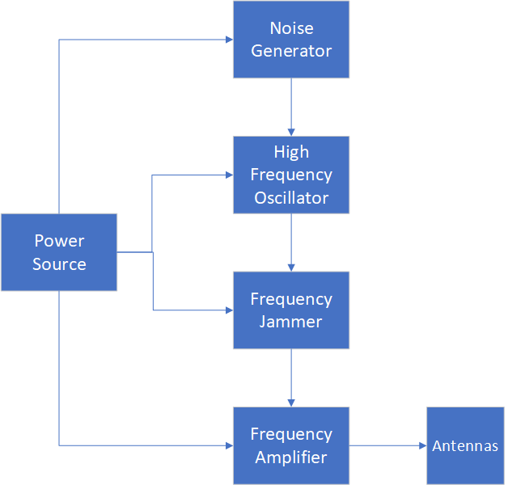

**Fig. 3.1: Circuit Block Diagram**

**3.2 Power Source**

The circuit is powered directly by AC current ranging (100V – 240V, 50 – 60Hz) due to the amount of current needed for the circuit to function effectively. The AC voltage is first stepped down to 12V DC using a transformer (TR1) and then using a Bridge rectifier of four diodes is converted to DC Current after which a smoothing and filtering capacitor is used to ensure proper filter of excesses which eventually gives an output of 12V 13A and output power of 156W Max. The circuit makes use of 7812 and 7805 to ensure that the 12V is regulated to 5V and 12V respectively and then supplied to the circuit. The circuit diagram for the power supply unit is given below;

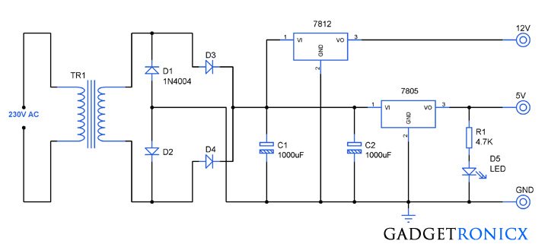

**Fig. 3.2: Power Source Circuit Diagram**

**3.3 The Noise Generator**

The noise generator is an oscillator made to generate high frequency up to 4MHz to interfere with the mobile signal. The part of the noise generator is divided into five (5) subparts which are the voltage divider, decompiling capacitor, feedback capacitor, tank circuit and a bypass capacitor. Without noise, the output of the VCO is just an un-modulated sweeping RF carrier. So, we need to mix the triangular signal with noise (FM modulating the RF carrier with noise). To generate noise signal, we used the Zener Diode operated in reverse mode. Operating in the reverse mode causes what is called avalanche effect, which causes wide band noise. This noise is then amplified and used in our system.

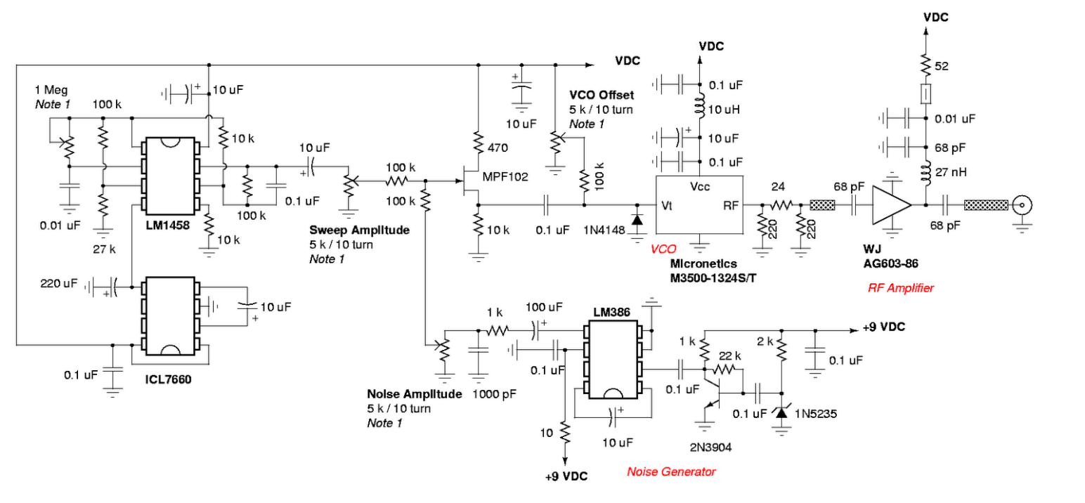

**Fig. 3.3: Noise Generator Circuit Diagram**

**Main Components of noise generating circuit**

* LM1458 Dual Operational Amplifier
* ICL7660 Voltage Converter
* MPF102 N-Channel JFET
* Micronetics M3500-1324S/T VCO (Voltage-Controlled Oscillator)
* WJ AG603-86 RF Amplifier
* LM386 Amplifier
* 2N3904 NPN Transistor
* 1N5235 Zener Diode

**3.3.1 Noise Generating Circuit Components**

* **LM1458:** Used as an oscillator to generate a sweep signal. The frequency of this sweep signal is controlled by the resistors and capacitors connected to it.
* **Potentiometers (Sweep Amplitude):** Adjust the amplitude of the sweep signal.
* **ICL7660:** Converts the positive supply voltage to a negative voltage which is used to drive other parts of the circuit.
* **MPF102:** Acts as a buffer and amplifier for the sweep signal. The potentiometer labeled "VCO Offset" adjusts the bias of the VCO control voltage.
* **Micronetics M3500-1324S/T VCO:** Generates the RF signal. The frequency of this oscillator is controlled by the voltage applied to its control input (Vt).
* **WJ AG603-86:** Amplifies the RF signal from the VCO to a higher power level suitable for jamming.
* **LM386:** Generates audio noise which is then amplified by the 2N3904 transistor and shaped by the Zener diode 1N5235. This noise is injected into the VCO control line to produce a noisy RF signal, enhancing the jamming effect.

**3.3.2 Noise Circuit Operation:**

* **Sweep Signal Generation:** The LM1458 generates a sweep signal whose frequency and amplitude are controlled by the surrounding resistors, capacitors, and potentiometers. This sweep signal is amplified by the MPF102.
* **Voltage Conversion:** The ICL7660 generates a negative voltage which is used by various components in the circuit.
* **RF Signal Generation:** The sweep signal modulates the control voltage of the VCO (Micronetics M3500-1324S/T), causing it to sweep across a range of frequencies. The RF output from the VCO is fed into the RF amplifier (WJ AG603-86), which boosts the power of the RF signal.
* **Noise Injection:** The noise generator (LM386 and 2N3904) creates a noise signal that is added to the control voltage of the VCO. This results in a noisy RF output, making the jamming signal more effective.
* **Frequency Jamming:** The combination of a sweeping frequency and injected noise means the jammer produces a broad, noisy signal. This signal can interfere with a range of frequencies, making it difficult for targeted devices to maintain a stable connection.

In summary, this circuit generates a broad-spectrum, noisy RF signal by combining a sweeping oscillator with a noise generator, and then amplifies this signal to interfere with the High Frequency Oscillator.

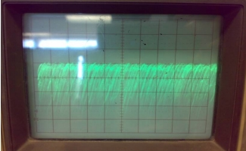

**Figure 3.4: Generated Noise Signal**

**3.4 High Frequency Oscillator**

The high frequency is an oscillator which generates frequency within the bandwidth of 200MHz - 700MHz with the help of the LC circuit which is parallel to each other. With the transistor Bfw30 having a frequency response of 1-1. 70Hz, therefore possess the potential to amplify the high frequency. The VCO in the high frequency oscillator is responsible for generating the RF signal which will overpower the mobile downlink signal.

The selection of the VCO was influenced by two factors, the frequency of the GSM system, which will be jammed and availability of the chip. For the first factor which implies that the VCO should cover the frequencies from 935MHZ to 960MHZ, 1900MHZ to 1980MHZ and 2100 to 2190 the MAX2623 VCO from MAXIM IC was found to be a good choice.

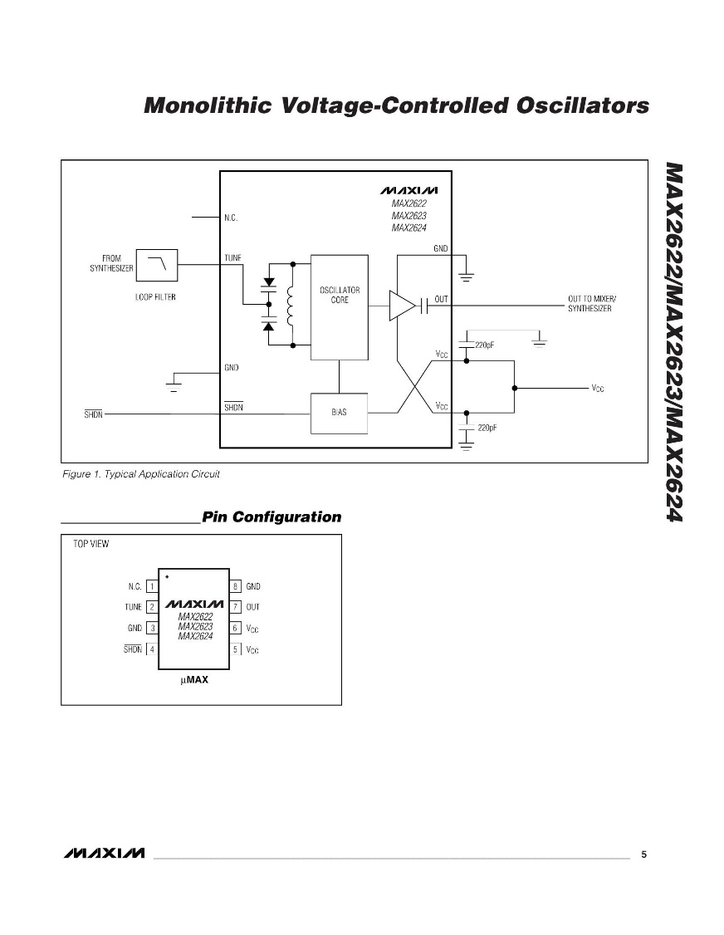

**Figure 3.5:** **MAXIM IC 2623**

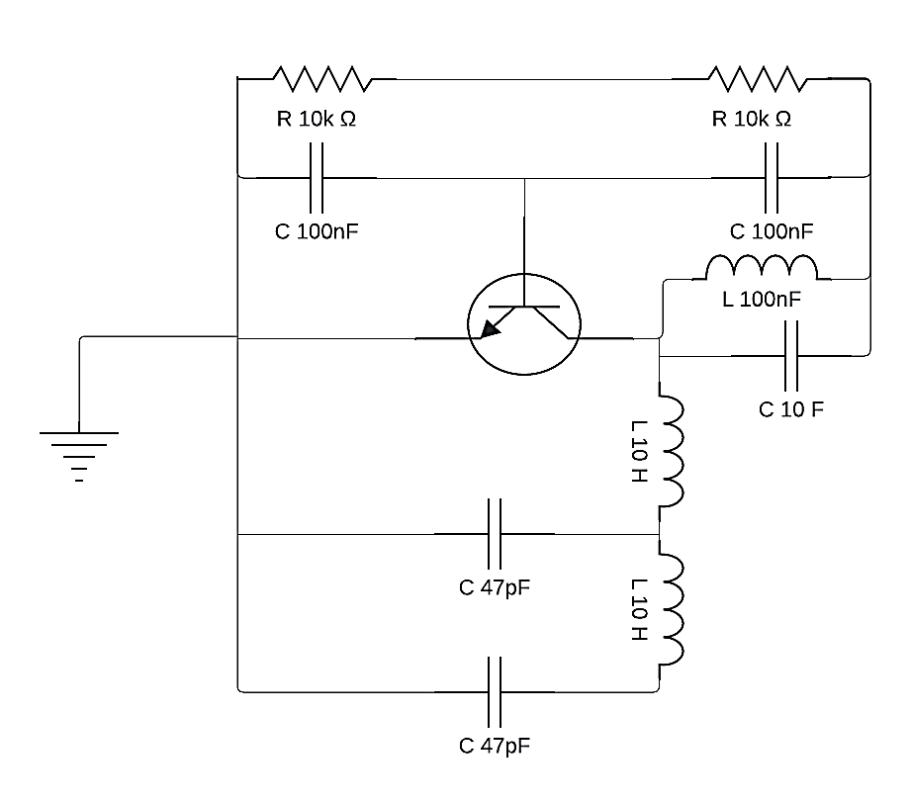

**Figure 3.6: High Frequency Oscillator**

**Mixing stage**

The mixing stage, the noise generator signal was mixed with the high frequency generator signal; hence the two were modulated to yield frequency close to the frequency modulation. where lower frequencies were interposed in the high frequency.

**3.5 Frequency Multiplier**

The frequency multiplier is a device in the system that increases the number of the frequency by two times or three times harmonic frequency of the input frequency. Where the input frequency = 900MHz Multiplying the frequency by 2, we will have. 900 x 2 = 1.8MHz. Therefore, this enables the frequency of the signal jammer to interfere with that of the mobile phone.

**Bandwidth:** The bandwidth of the frequency ranges from 45MHz to 1.8MHz. Any frequency of any receiver and transmitter that falls within this bandwidth will be interfered with by the signal Jammer

**3.6 Frequency Amplifier**

Frequency amplifier is a common base amplifier which has a low impedance and has high output

impedance, in which the collector is connected to the tank circuit which also forms the circuit

load. The output impedance is as high as 50KO, the amplifier can respond to frequency from a

very low value to a high value of 1.8GHz.

**3.7 Component’s Values**

Where C, Capacitor; L, Inductor; Q, Transistor; R, Resistor

Therefore C1:10nF, C2:470Pf, C3:20pF, C4:1nF, C5:1OOnF, C6:47pF, C7:30pF, 2pF (variable capacitor) C8:12600pF, Ll:30uH, L2:5OuH, L3:20uH, L4:10uH, L5:2uH, Q1:Be337, Q2:BFW30, R1:10KΩ, R2:47KΩ, R3:22KΩ, MAXIM IC 2623, LM1458, ICL7660, MPF102 N-Channel JFET, Micronetics M3500-1324S/T VCO (Voltage-Controlled Oscillator), WJ AG603-86 RF Amplifier, LM386 Amplifier, 2N3904 NPN Transistor and 1N5235 Zener Diode

**3.8 Signal Strength**

The signal strength or power density (p.d) of the jammer is given by

p.d = Pt / 4 ( 3.142 * (r2) )

That is, the power density of the transmitter (either from the jammer or from the base station) to

the receiver (mobile phone) is directly proportional to the transmitting power & indirectly proportional to the square of its distance "r" between the transmitter and the receiver

Pt = V2 / Rt, Rc = total collector reactance were p.d = power density

Pt = Transmission Power

R = Radius Covered

Rt = XL + Xc

Inductance reactance XL= 2xfl and the capacitance reactance Xc = 1 / (2xfc)

Assuming frequency f = 820Mhz, C = 2pF and L = 2uH therefore,

XL = 2 * 3.142 * 820 * 106 * 2 * 10-6 = 10305Ω

Xc = 2 * 3.142 * 820 * 106 * 2 * 10-12 = 97.03Ω

Therefore, the total reactance connected

In parallel Xc // XL = (97 * 10305) **/** (97 + 10305) = 96Ω

The amplifier base resistor connected in parallel

Rb = ( ( 22 * 103 + 273 ) **/** ( 22* 103 * 27 * 103 ) ) = 12122.4Ω

Voltage across 22Ω = ( ( 22 * 103 * 9 ) **/** ( 22 * 103 + 27 * 103 ) ) = 4v

Amplifier base current lb = Vb / Rb = 4 / 12122.4 = 0.00033Amp

Ic = Ib * B (Amplification Factor)

Ic = 0.00033 * 200 = 0.06Amp

Collector Voltage Vc = Ic * Rc = 0.06 * 96 = 5.76v

Transmission Power (Pt) = V2 / Rc = 5.762  / 96 = 0.3456W

If the radius is taken be 1m, therefore the power density will be

p.d = ( Pt / A ) = Pt / ( 4 * 3.142 * ( r * r ) ) = 0.3456 / ( 4 * 3.142 * ( 1 * 1 ) ) = 0.027

**CHAPTER 4**

**RESULTS AND DISCUSSION**

**4.1 Result**

The circuit is carefully and correctly connected as shown in the circuit diagram above with it power source switch off. A mobile phone (GSM) is brought close to the area where the jamming circuit is to be tested.

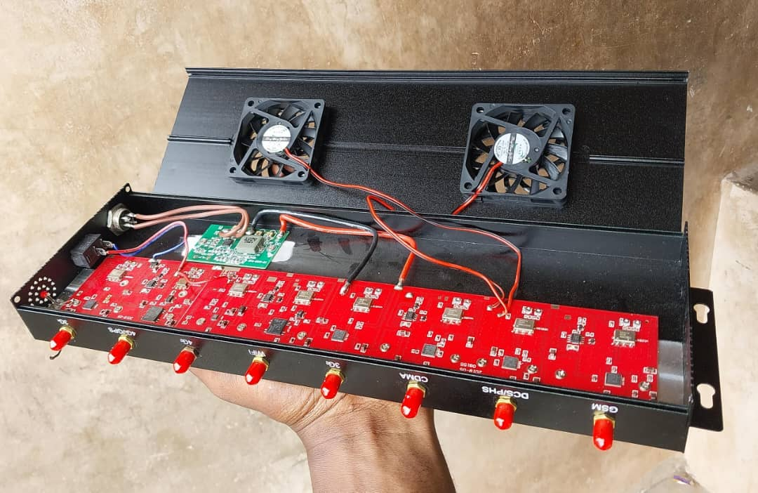

**Figure 4.1: Front view of GSM Jammer**

The network service in the handset (GSM) is confirmed by physically observing the network service in the handset through the screen of the handset. The network service in the GSM is also confirmed by dialing a number from the GSM phone A or by receiving a call from another GSM phone B which could either be within or outside the area were the GSM phone A is. A call made or received from the GSM phone A, confirmed the presence of network service in the phone –Switch ON the jamming device: When the jamming device is switch on, it will be observed that the network service which was on the GSM disappears with an inscription “emergency call only” on the GSM phone screen. This, therefore, shows that the signal or service in the GSM phone have been blocked or interfered with.

**4.2 Confirmatory Test.**

While the jamming device is still on, try to make a call with the GSM phone A from the area where the jamming device is. It will be observed that call making from the jamming area will be impossible. With the jamming device still on, if the second GSM phone B with a network service that is outside the jamming area tries to reach or call the other GSM phone A that is in the jamming

area, it will observe that the GSM phone A will not respond to the incoming call from GSM phone B, hence GSM phone A signal has been jammed.

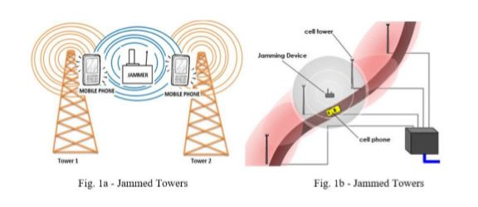

**Fig 4.2 The Operation of a Mobile Phone Across A Jammer to Tower**

**4.3 Observations**

In the cause of testing the mobile phone signal jamming device, it was observed that the jamming device, jammed / interfered with the TV transmitting signal (frequency) and some frequency bandwidth and a radio receiver was also observed to be blocked by the jamming device and the GSM Jammer couldn’t interfere with high frequency GSM unless the GSM devices were switched off and turned on back after which the devices were unable to connect to the base station and where adequately jammed. All other devices within 5 meters were successfully disconnected from the base station as their signals where jammed.

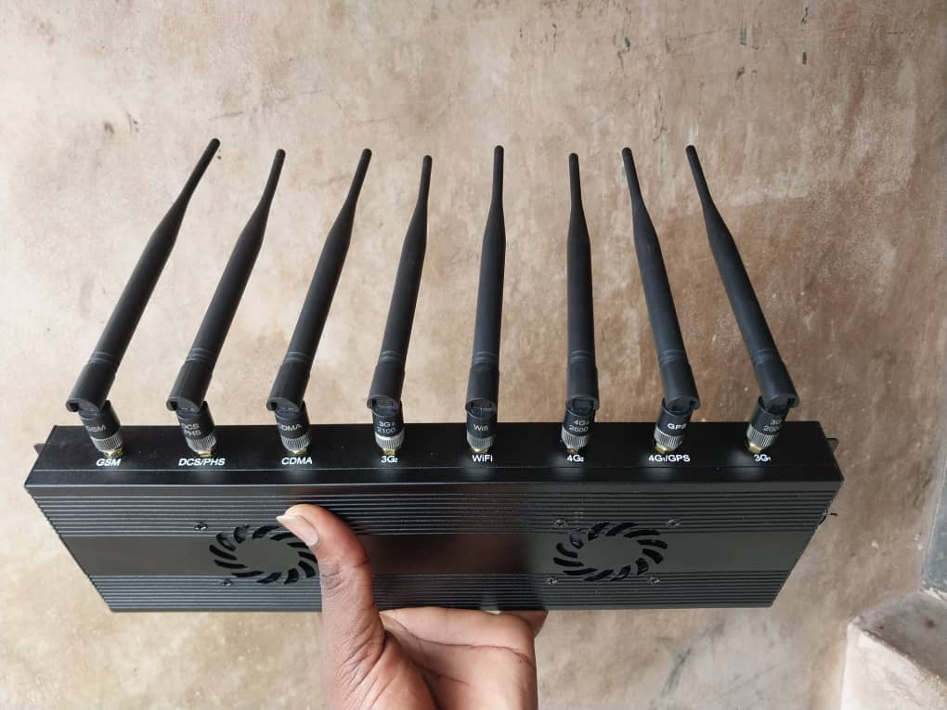

**Figure 4.3: Frequency Jammer (Turned on)**

**4.4 Observation Procedure**

-Switch on a TV.

-Bring the jamming device close to where the T. V is and ensure that the device is off.

-While the TV show (program) is in progress, switch on the jamming device

-The ongoing TV show will be observed to stop transmitting.

-The TV show will start transmitting again when the jamming device is switched off.

The effect of the jamming device was observed to reduce with distance i.e. the strength

of the jamming device is inversely proportion to the distance between the jamming device and

the jammed device (OSM).

The longer the distance between jamming and the jammed device the less effective the jamming will be, while the lesser the distance between the jamming device (mobile phone jammer) and the jammed device (OSM phone) the more effective the jamming will be.

**4.5 Limitations**

The mobile phone signal jammer was primarily aimed at blocking mobile phone frequency, The

blocking of TV, radio and other receivers whose frequencies fall within the jamming operating

frequency was not intended. Therefore, with the above drawback, the use of a mobile phone jammer is limited to places where TV, radio, and other devices that operate within the frequency of the jammer device is not allow. Another drawback of the GSM jammer is its inability to immediately disconnect or jam devices with stronger Frequencies that are already connected to the base station, but is effective at preventing devices from re-connecting to the base station when the GSM jammer is already on.

**CHAPTER FIVE**

**CONCLUSION AND DISCUSSION**

**5.1 Conclusion**

A mobile phone signal jammer is a device that is used to interfere with a mobile phone frequency

or used to restrict the use of mobile phone in some quite required area e.g. churches, mosques,

meeting rooms, lecture halls etc.

Jamming of mobile phone frequency is achieved by sending a noise signal with frequency equal to or a bit greater than the transmitting frequency of the network service which is been used by the mobile phone. The strength of the jamming device, increase in the distance between the jamming device and the phone, and also decrease with increase in the distance between the jamming device and the phone to be jammed.

The mobile phone jamming device can interfere with TV, radio, mobile phone and other Frequencies lesser than that. frequencies which was not intent; this can therefore be seen as a disadvantage in the use of mobile phone signal jammer because this limits the areas where the device can be use. This jamming device can also jam TV frequency. Apart from that the GSM jammer is only capable of jamming devices which try to connect afresh to the base station of an area after the frequency jammer has been turned on.

**REFERENCES**

1. Scourias, J. (1997). Overview of the Global System for Mobile Communications. University of Waterloo.
2. Jisrawi, N. (2006). The Use of Mobile Phone Jammers in Combatting Remote Detonated Explosives. Journal of Defense Technology.
3. Adediran, S. (2004). Radio Frequency Interference in Mobile Communications. IEEE Communications Magazine.
4. Zanger, C. (2002). Efficient Energy Use in Signal Jamming. International Journal of Signal Processing.
5. Gilgor, V. (2007). Military Communication Jamming Strategies. Military Technology Review.
6. Chirag, K., & Nitin, D. (2014). Advances in Mobile Phone Jamming Technologies. International Journal of Mobile Network Design and Innovation.
7. Kwansah, A. K. (2018). Design and Implementation of GSM Jammers. Journal of Telecommunications.
8. Arowolo, O., & Adekunle, A. (2019). Intelligent Mobile Phone Jamming Systems. International Journal of Wireless and Mobile Computing.
9. Fundamental physics. Extended by David Halliday, ~obert Resnics and Jearl Walker. ISBN 9971-51-330-7
10. Jerome S. Berg (2008). [Broadcasting on the Short Waves, 1945 to Today](http://books.google.com/books?id=Ux9fZj6izuEC&pg=PA46). McFarland. pp. 46–. [ISBN](https://en.wikipedia.org/wiki/International_Standard_Book_Number) [978-0-7864-5198-2](https://en.wikipedia.org/wiki/Special:BookSources/978-0-7864-5198-2).
11. [NIST 800-97 Establishing Wireless Robust Security Networks: A Guide to IEEE 802.11i](http://csrc.nist.gov/publications/nistpubs/800-97/SP800-97.pdf)
12. ["Radio Northsea International"](http://www.bobleroi.co.uk/ScrapBook/RobinBanksPt2/RNIwithRobinBanks2.html). <http://www.bobleroi.co.uk>. Bob Le-Roi. Retrieved 23 May 2012.
13. Office of Research, USIA (1983), [Jamming of Western Radio Broadcasts to the Soviet Union and Eastern Europe](http://www.radiojamming.puslapiai.lt/doc_en.htm), United States Information Agency
14. ["ARCHIVE DOCUMENTS"](http://www.radiojamming.puslapiai.lt/doc_en.htm). www.radiojamming.info. Radio Baltic Waves.
15. ["Russian Jammers"](http://www.laughingpoliceman.com/jammers.htm). The Laughing Policeman Wireless Society. The Laughing Policeman Wireless Society.
16. Office of Research, USIA (various), [Radio Free Europe archive documents](http://www.radiojamming.puslapiai.lt/doc_en.htm), United States Information Agency Check date values
17. Rimantas Pleikys. ["JAMMING BY THE FREE WORLD"](http://www.oldradio.lt/jamming/page011.htm). JAMMING by Rimantas Pleikys. R. Pleikys. p. 11.
18. Ludger Schadomsky (28 May 2010). ["Jamming of DW is part of Ethiopia's campaign against press freedom"](http://www.dw.de/dw/article/0,,5628598,00.html?maca=en-rss-en-all-1573-rdf). Deutsche Welle: Press Freedom. Deutsche Welle.